CS 255 System Design Document Template

This template lays out all the different sections that you need to complete for Project Two. Each section has guidance to prompt your thinking. You will need to continually reference the interview transcript as you work to make sure that you are addressing your client’s needs. There is no required length for the final document. Instead the goal is to complete each section based on what your client’s needs are. Remove this note when you are finished, and replace all bracketed text with the relevant information.

UML Diagrams

UML Use Case Diagram
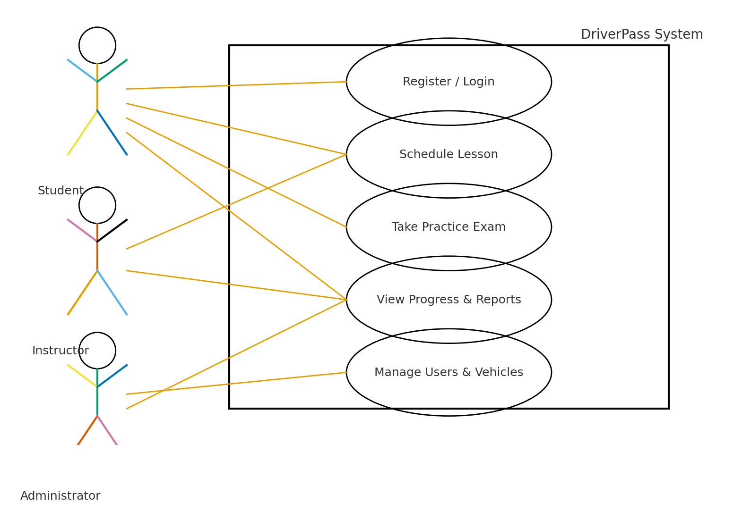
Description:
The use case diagram represents the major user interactions within the DriverPass system. Students can register, log in, schedule driving lessons, access online study materials, and complete DMV practice tests. Instructors can manage student schedules and submit progress updates. Administrators oversee user data, manage drivers and vehicles, and handle lesson approvals. IT Admins maintain system operations, perform account recovery, and manage access permissions.

UML Activity Diagrams
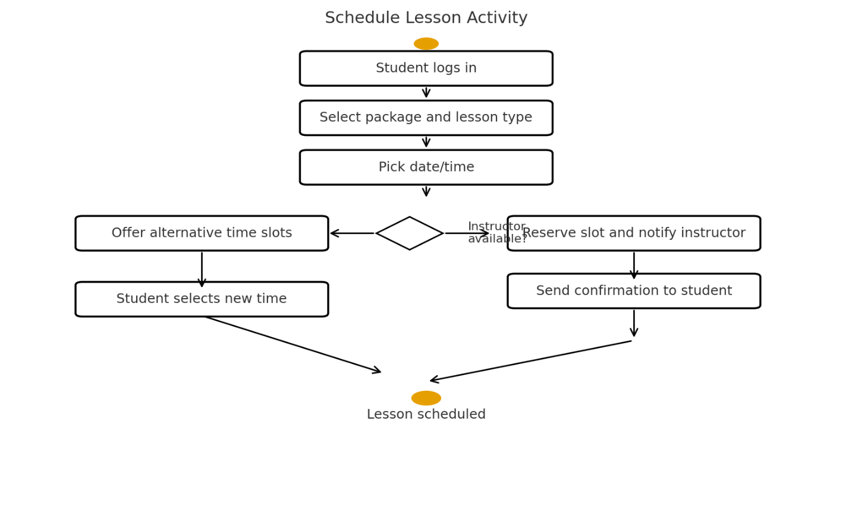

Description:
The first activity diagram illustrates how a student books a driving lesson. The process begins with login authentication, followed by lesson package selection, time slot reservation, confirmation, and notification. The second activity diagram shows the steps for taking an online practice exam, from selecting the test to viewing results and progress tracking.

UML Sequence Diagram
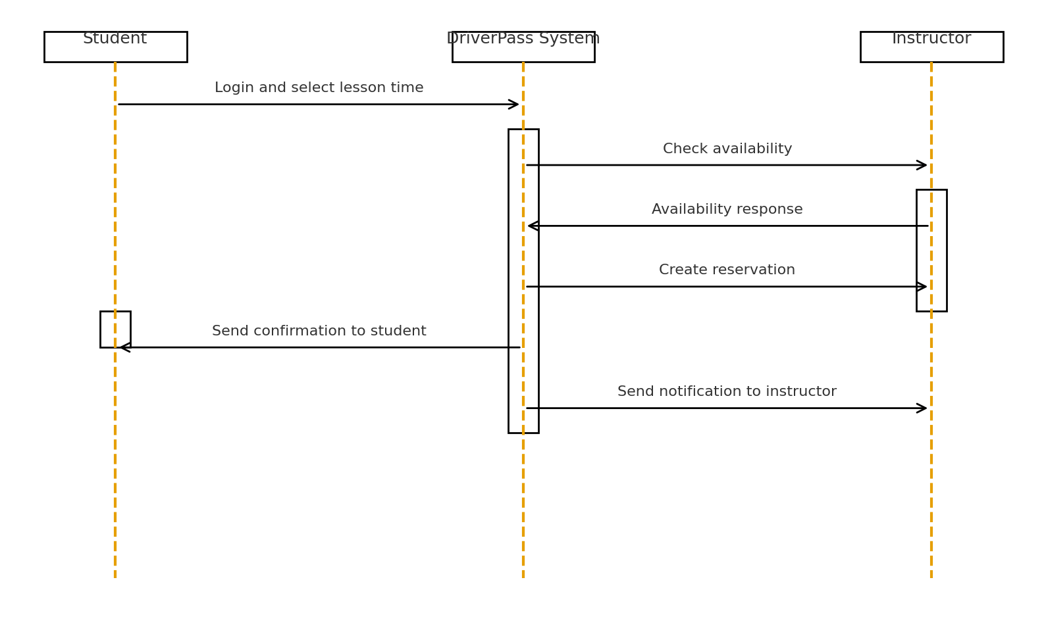

Description:
The sequence diagram shows the interaction between the Student, the DriverPass system, and the Instructor. The student selects an available slot, the system verifies instructor availability, and once confirmed, updates the shared schedule and sends a confirmation notification to both parties.

UML Class Diagram
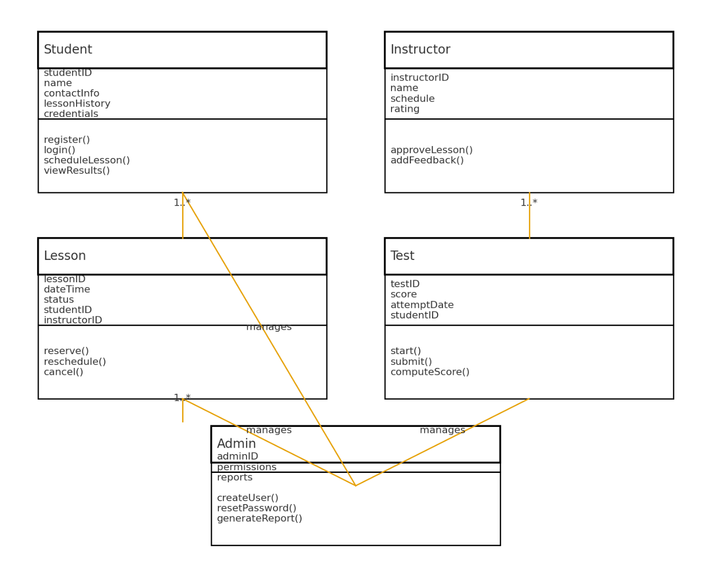
Description:
The class diagram represents the structure of the DriverPass system using key classes and their attributes. Examples include:
- Student: studentID, name, contactInfo, lessonHistory
- Instructor: instructorID, schedule, rating
- Lesson: lessonID, dateTime, status, instructorID, studentID
- Test: testID, score, attemptDate
- Admin: adminID, permissions, reports
Associations demonstrate how Students are linked to Lessons and Tests, while Admins oversee data and reports.

Technical Requirements
The DriverPass system requires a cloud-hosted web application environment with the following specifications:
- Hardware: Cloud infrastructure supporting virtual machines and storage redundancy.
- Software: Web framework (e.g., Java or Python backend with MySQL database), HTML/CSS/JavaScript frontend.
- Tools: Secure login API, DMV data integration API, SSL certification for secure communication.
- Infrastructure: AWS or Azure for scalable hosting with regular automated backups.
- Compatibility: Runs on Windows, macOS, and major browsers (Chrome, Firefox, Edge, Safari) and mobile access through responsive design.

System Requirements
Functional Requirements:
- The system shall allow users to register, log in, and manage their profiles.
- The system shall allow students to schedule, modify, and cancel lessons.
- The system shall allow students to take practice exams and review scores.
- The system shall allow instructors to update lesson status and provide feedback.
- The system shall allow administrators to manage lessons, vehicles, and user data.
- The system shall generate reports for administrators on lesson activity and exam performance.
Nonfunctional Requirements:
- The system shall maintain 99.9% uptime for availability.
- The system shall load web pages within 3 seconds under normal use.
- The system shall encrypt sensitive data (AES-256 or higher).
- The system shall be scalable to support 10,000+ concurrent users.
- The system shall maintain data backup and disaster recovery capabilities.

Security
The DriverPass system incorporates multiple layers of protection to safeguard user data and system integrity.
- User accounts require secure authentication with encrypted passwords.
- HTTPS and SSL ensure secure communication between client and server.
- Accounts are locked after three unsuccessful login attempts to prevent brute-force attacks.
- IT Admins manage role-based permissions for Students, Instructors, and Administrators.
- Automated password reset process for account recovery.
- Regular vulnerability scans and patch updates.

System Limitations
While the system provides robust functionality, a few limitations exist:
- Limited to web-based access; no native mobile application.
- Dependence on internet connectivity for system operations.
- Initial DMV integration is limited to available APIs and may require future expansion.
- Budget and time constraints may restrict advanced reporting features during early releases.
- Cloud hosting relies on third-party uptime guarantees.

Summary
As the systems analyst for DriverPass, I designed this solution to create a secure, efficient, and scalable learning management and scheduling system. The DriverPass platform bridges the gap between online study and hands-on driving instruction, supporting both student success and operational efficiency. This design ensures clear communication between users, accurate scheduling, reliable progress tracking, and data security across all roles.

